EEL-4742L Advanced Microprocessor Based System Design Lab Report

Section No: 1
Lab Instructor: Angel Salges
Lab No: 1
Lab Title: Using Memory Mapped I/O with the MSP432
Name: Jacob Bachle
Partner’s Name: Rafael Cano
Date Performed: 1/20/26
Date Delivered: 1/20/26

Contents
EEL-4742LAdvanced Microcontroller Based Systems Design Lab Report 1
1. Introduction 3
2. Design Requirements 3
3. Theoretical Design 3
4. Synthesized Design 4
5. Experimental Results 4
6. Summary 4
7. Lessons Learned 5

Introduction
Configuring GPIO pins can be completed on a lower level then using driver library functions. The bits associated with the register that stores information about the ports configuration can be easily written or cleared. Depending on which bit on the port registers is written or cleared, a particular pin can be configured exactly to meet any specifications. This is accomplished by completing 4 “mini labs” that each have separate requirements for configuring input and outputs. The driver library or SDKs provided by developers or microcontroller manufacturer may use different syntax. While functions created by developers or the microcontroller manufacturers themselves may use varying syntax, writing or clearing registers will always use similar syntax. This is why being able to use register level code is important when dealing with a wider range of microprocessors.

Design Requirements
When the device is powered on, LED 1 and the colored LEDs are all turned off and not blinking.

When switch 1 (S1), located on the left side of the board, LED 1 can be toggled to blink at the following frequencies, 1, 2, 4, and 0 (Off) Hz. The states are toggled when S1 is released.

When switch 2 (S2), located on the right side of the board, the colored LEDS can be toggled to different colors. The colors are Red, Green, Blue, None (Off). The state are toggled when S2 is released

Theoretical Design
Lab 1d pseudocode:
- Stop WTD
- Set / Clear timer source to default frequency (MCLK) which is 3 MHz.
- Set RED LED 1 as GPIO output
- Set RED LED 2 as GPIO output
- Set RED LED 1 OUT low (Px.yOUT)
- Set RED LED 2 OUT low (Px.yOUT)

- Set GREEN LED 2 as GPIO output
- Set BLUE LED 2 as GPIO output
- Set GREEN LED 2 OUT low
- Set BLUE LED 2 OUT low

- Set S1 as GPIO input
- Enable pull up/down resistors for S1
- Set pull up resistor for S1
- Enable interrupt edge for S1
- Select interrupt edge High to Low for S1
- Clear S1 interrupt flag

- Set S2 as GPIO input
- Enable pull up/down resistors for S2
- Set pull up resistor for S2
- Enable interrupt edge for S2
- Select interrupt edge High to Low for S2
- Clear S2 interrupt flag

- Initialize type def for blink frequency
- Initialize type def for color pattern

- While (1)
  - If S1 IFG is set
    - Step through blink frequency type def (implement proper roll over logic)
    - Clear S1 interrupt flag
  - If S2 IFG is set
    - Step through color pattern type def (implement proper roll over logic)
    - Clear S2 interrupt flag
  - Set delay according to blink frequency type def
  - Turn off all LEDs
  - Set LEDs to turn on according to color pattern in type def

Synthesized Design

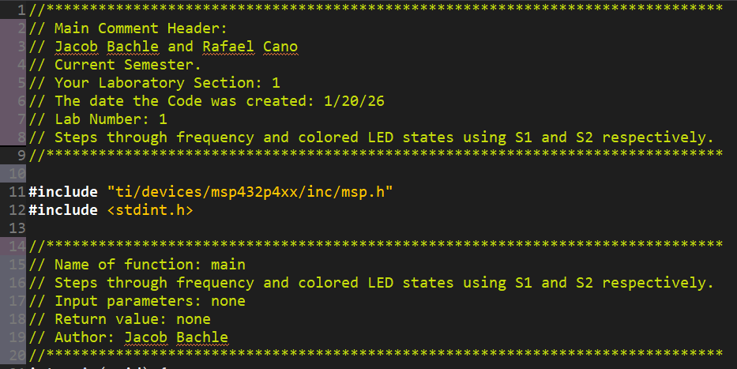
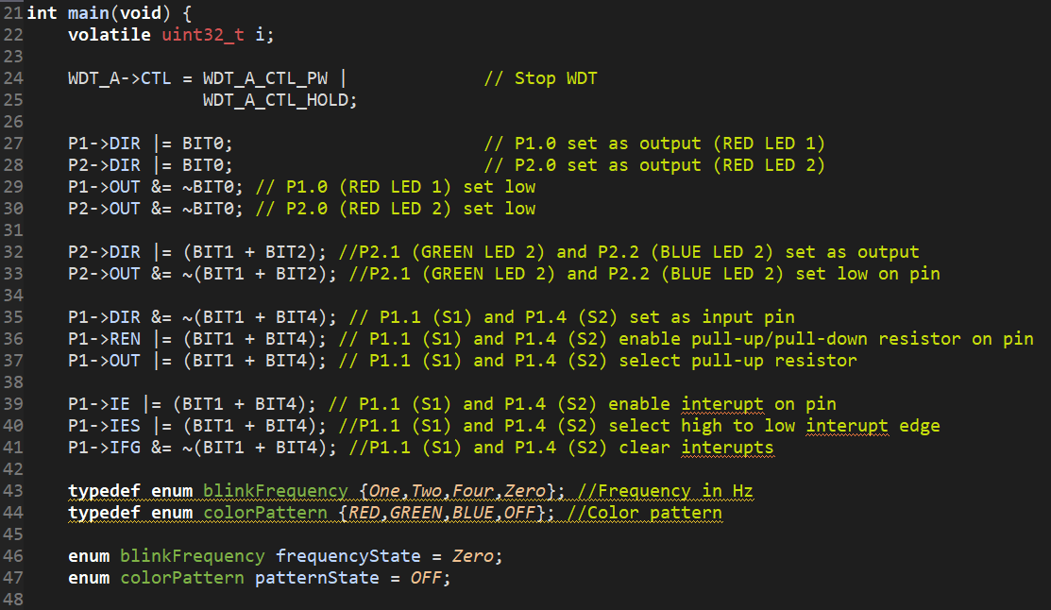
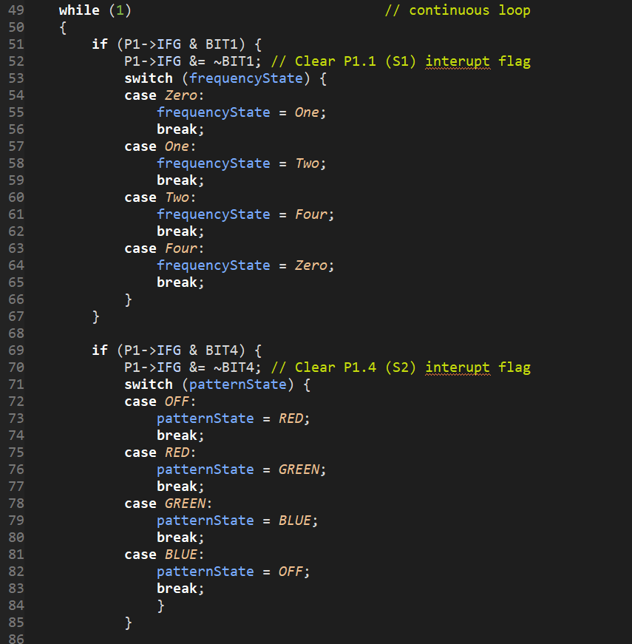
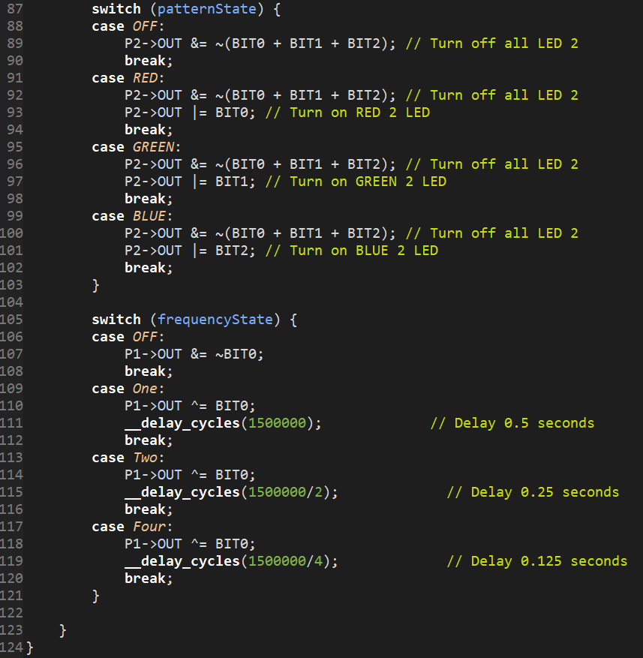

Experimental Results
The following certification is proof of design meeting design requirements.
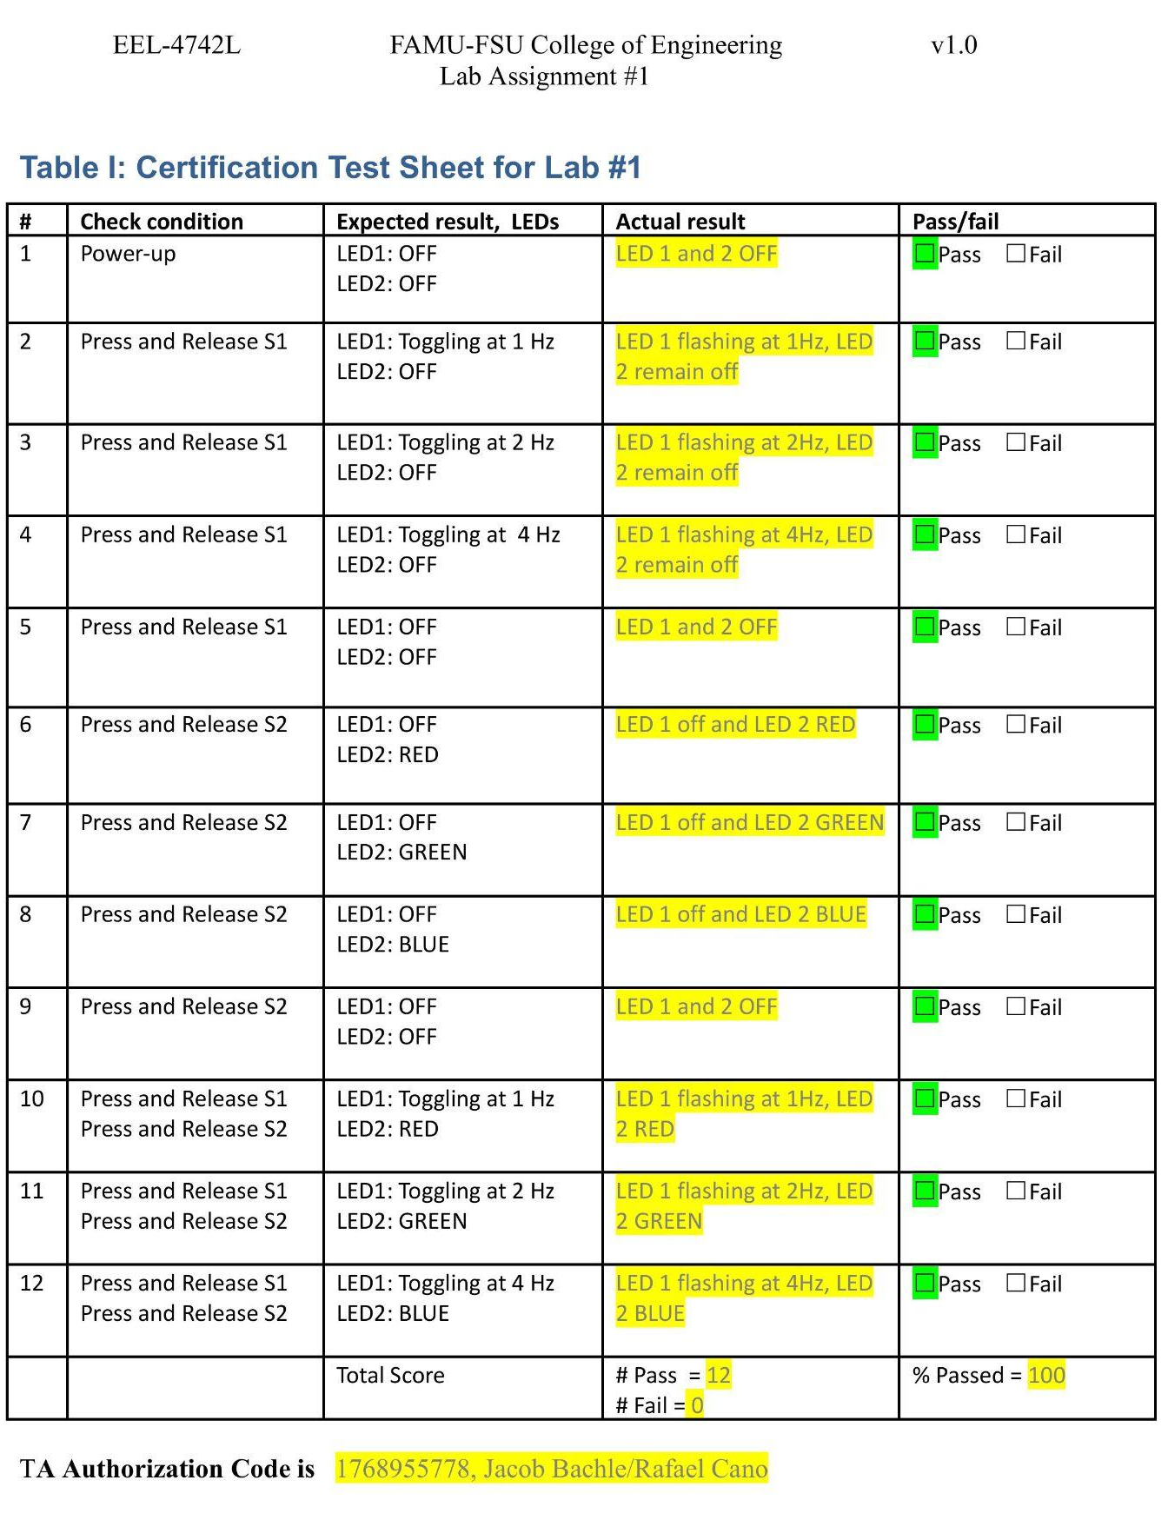

Summary
Lab 1d, the frequency for RED LED 1 is controlled by a switch case statement that depending on the current state, a specific delay value is used. This current state is stored as an enum typedef so the index can be mapped to an exact delay value. And when the switch controlling the frequency is pressed, the enum typedef can be incremented with rollover logic to switch the current state to the new state. The color changing LED state is stored and updated in the same way. A different enum typedef is used with each state, mapping to a combination of LED 2 leds. When the colored LEDS are updated, instead of unique delay values being the defining feature, the combination of different colored leds, located on port 2, are used to display the corresponding colored state.

With the implementation of this logic, all 12 out of 12 tests are passed. This means that 100% of the final design tests were passed and no further modifications needed to be made.

Lessons Learned
List of new concepts learned:
- Configure input pins with register level code.
- Configure output pins with register level code.
- Configure, clear, and check interrupts on a pin with register level code.

In the future, using driver library functions can be used in order to make the code more readable. Register level coding is very specific and the code does not provide much information if no comments are provided. In addition, to provide the same amount of information as driver library functions, code comments can be used to describe the purpose and function of the register level code. This was completed in the lab and made it very easy to edit and read the register level code. The process of commenting important information about the purpose and functionality of the code will be repeated in future labs.

